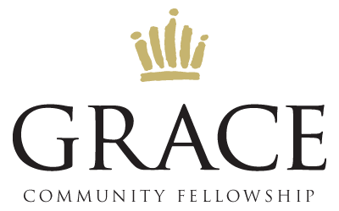

2021 Summer Event Schedule

DATE | EVENT | YOUTH | CHILDREN | NURSERY
6/16 | Game Night  GCF BRENHAM | Participating | Church | Yes
6/30 | Family Movie Night  WESTWOOD CINEMA 6 (BRENHAM) | Participating | Participating | No
7/12 | Splashway Family Day  SPLASHWAY WATERPARK (SHERIDAN) | Participating | Participating | No
7/28 | Guess Who’s Coming to Dinner  VARIOUS HOMES | Church | Church | Yes
8/15 | Family Swim Night  BLUE BELL AQUATIC CENTER | Participating | Participating | Yes
8/25 | Worship & Prayer Night  GCF BRENHAM | Participating | Participating | Yes
9/1 | Life Group Celebration  FIREMAN’S PARK | Participating | Participating | No
9/8 | Life Groups & Ministries Resume  2021-2022 SEMESTER KICKOFF | Church | Church | Yes

NOTE:
On nights when the Nursery & Children’s Ministry are operating, they are only
for those parents who are participating in that evening’s event.

